Ideation Phase
Brainstorm & Idea Prioritization Template

Date | 20 October 2026
Team ID | Niharika Suhane
Project Name | IMovies – Movie ticket booking made simple.
Maximum Marks | 4 Marks

Brainstorm & Idea Prioritization Template:
Brainstorming provides an open and collaborative environment where the team can share creative ideas to improve the movie ticket booking experience. All ideas are welcomed, helping the team identify user problems such as complicated booking steps, unclear pricing, seat availability, and payment failures.
Use this template to brainstorm solutions for IMovies – Movie ticket booking made simple, prioritize user needs, and develop ideas for a smooth, fast, and convenient ticket booking experience.
Reference: https://www.mural.co/templates/brainstorm-and-idea-prioritization
Step-1: Team Gathering, Collaboration and Select the Problem Statement

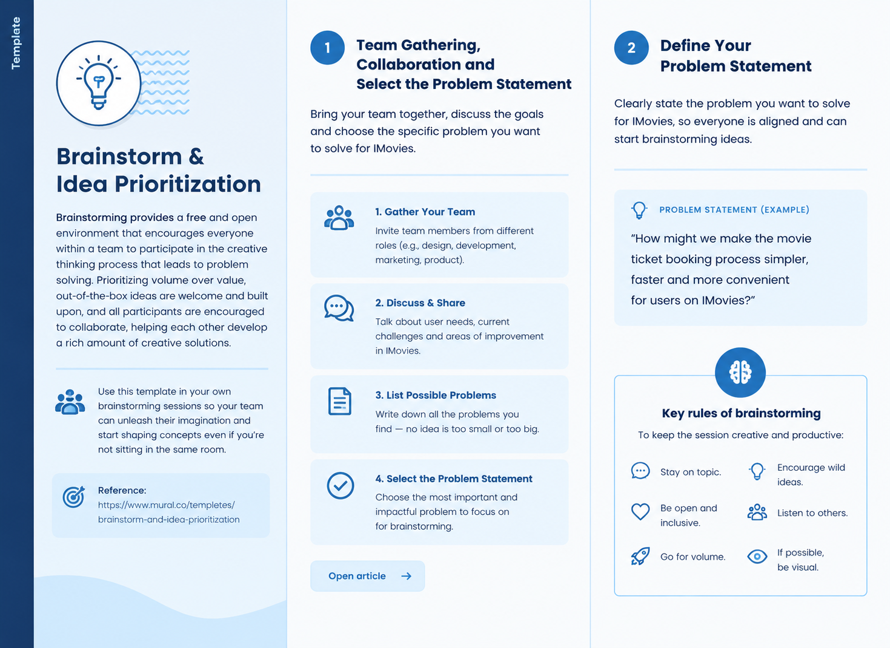

Step-2: Brainstorm, Idea Listing and Grouping
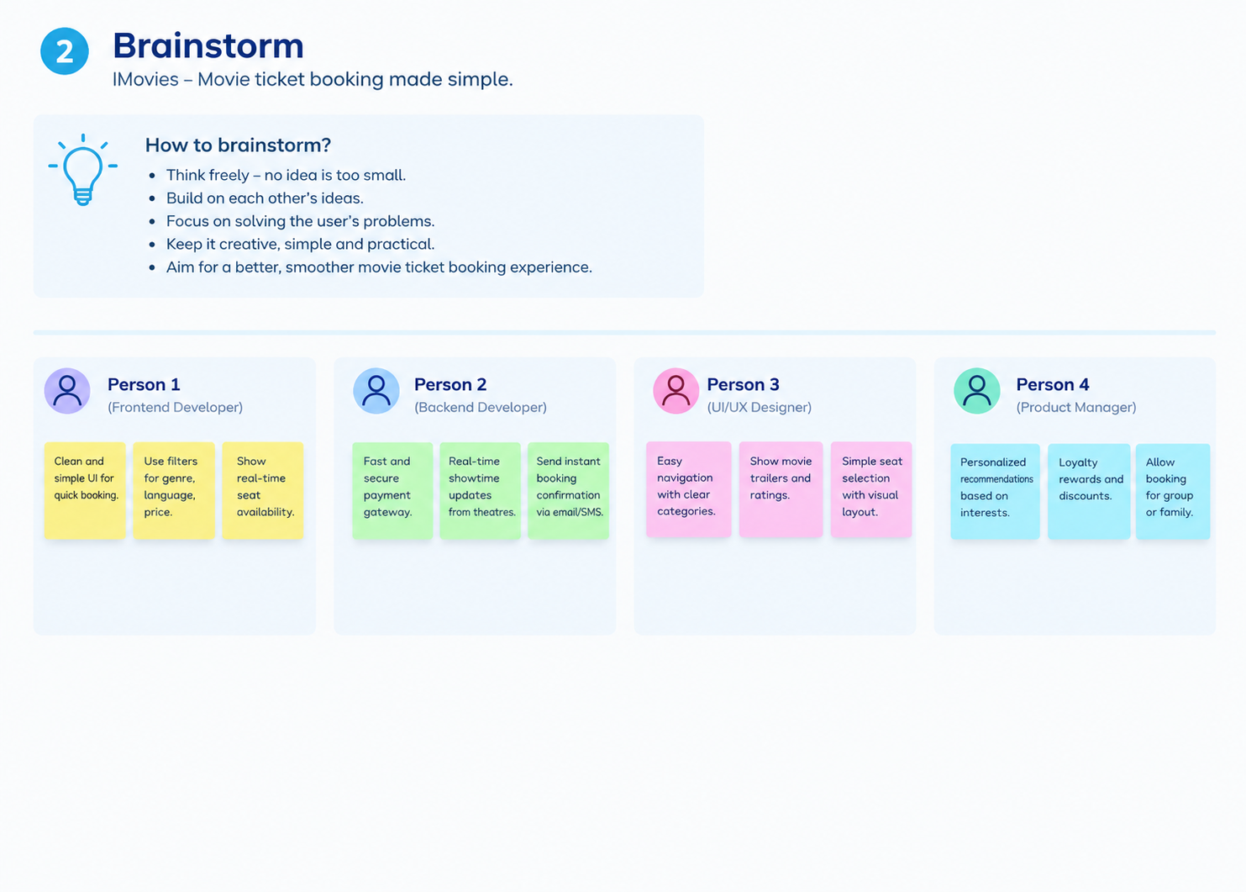
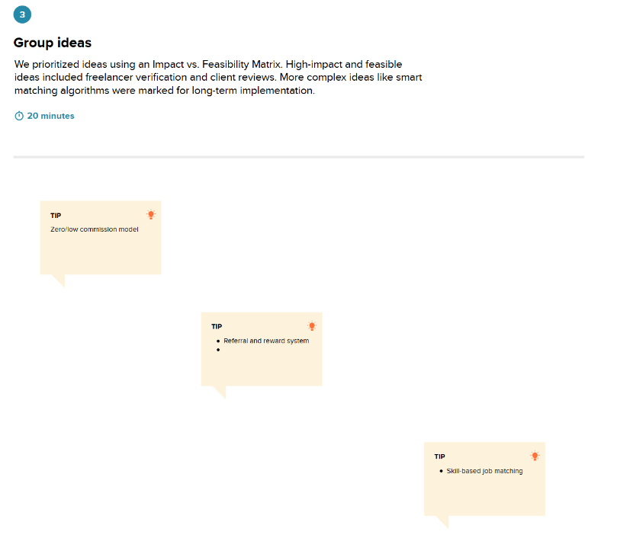

Step-3: Idea Prioritization
